
MONEY-BACK GUARANTEE AGREEMENT
This Agreement ("Agreement") is made and entered into as of [Date], by and between I'm Canada, hereinafter referred to as the "Firm", and [Client's Full Name], hereinafter referred to as the "Client".

1. SERVICES PROVIDED:
The Firm agrees to provide immigration legal services to the Client, specifically related to the application for a study permit in Canada. The service, titled "Study Permit Application," will include an immigration lawyer from the Firm filing on behalf of the Client to the Immigration, Refugees and Citizenship Canada (IRCC).

2. COST OF SERVICE:
The total cost for the "Study Permit Application" service is $2,500 USD.

3. MONEY BACK GUARANTEE:
The Firm offers a complete money-back guarantee to the Client under the following terms:
a. If the Client's study permit application is refused, the Client has the option to:
i. Receive a full refund of the amount paid, minus the $150 government fee.
ii. Request the Firm to re-apply for the study permit on their behalf at no additional cost.
b. The money-back guarantee is void under the following conditions:
i. If the Client has had a previous study permit refusal.
ii. If the Client has previously applied for Express Entry.
iii. If the Client wishes to apply together with family members.
iv. If the Client wishes to apply not from their country of citizenship/permanent residence.
v. If the Client is deemed “inadmissible” by the Canadian government.
vi. If the Client refuses or fails to provide legal documents to the Firm.

4. PAYMENT:
The Client agrees to pay the Firm a fee of $2,500 USD for the "Study Permit Application" service, of which $150 is a non-refundable government fee.

5. TERMINATION:
Either party may terminate this Agreement at any time, with written notice. In the event of termination, the Firm will refund the Client's payment minus any non-refundable fees and any work already performed.

6. CONFIDENTIALITY:
Both parties agree to maintain the confidentiality of all information obtained during the execution of this Agreement.

7. GOVERNING LAW:
This Agreement shall be governed by and construed in accordance with the laws of Canada.

8. AMENDMENTS:
Any changes or modifications to this Agreement must be in writing and signed by both parties.

9. ENTIRE AGREEMENT:
This Agreement contains the entire agreement between the parties and supersedes all prior negotiations, understandings, and agreements between the parties.

10. ACKNOWLEDGEMENT:
By signing below, the Client acknowledges that they have read, understood, and agree to the terms and conditions of this Agreement.

I'm Canada - Max Medyk (CEO)
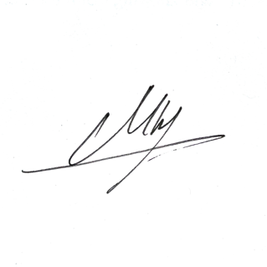
Date: September 21, 2023

Signature:

[Client's Full Name]

Date: ________

Signature:

